Itgalpura, Rajanukunte, Bengaluru - 560064

**School of Engineering**

A Project Report on

# “Smart Bot Detector Using Ultrasonic Sensor”

Submitted in partial fulfillment of the requirement for the course

Innovative Project - Arduino using embedded C (**CSE 1002**)

Submitted by   
 Group: IPC 19

|  |  |
| --- | --- |
| Student Name | Roll No |
| NEHA R | 20211CSE0224 |
| VAISHALI PATEL V | 20211ECE0200 |
| ADNAAN FAROOKI | 20211ECE0063 |
| AKSHAY RATHOD | 20211CSE0222 |
| ABHISHEK RATHOD | 20211CSD0046 |
| YASHWANTH KUMAR S | 20211EEE0027 |

Under the supervision of

**Guide name: Dr. A Jayachandran**

**Designation: Professor**

**Department: Computer Science And Engineering**

JUNE 10th ,2021-22

**Abstract :**

Smart Bot Detector senses obstacles in the path, avoids it and resumes its running**.** It is a robot that avoids the obstacle which comes in its path and navigates in unknown environment by avoiding collisions.

Ultrasonic sensors are used primarily as proximity sensors. They can be found in automobile self-parking technology and anti-collision safety systems. Ultrasonic sensors are also used in robotic obstacle detection systems, as well as manufacturing technology. In comparison to infrared (IR) sensors in proximity sensing applications, ultrasonic sensors are not as susceptible to interference of smoke, gas, and other airborne particles (though the physical components are still affected by variables such as heat).

Our project is based on Robotics and AI.

The application of the Obstacle Avoiding robot is not limited and it is used in most of the military organizations now which helps carry out many risky jobs that cannot be done by any soldiers. Ultrasonic sensor is used to sense the obstacles in the path by calculating the distance between the robot and obstacle. If robot finds any obstacle it changes the direction and continue moving.

Before going to build the robot, it is important to understand how the ultrasonic sensor works because this sensor will have important role in detecting obstacle. The basic principle behind the working of ultrasonic sensor is to note down the time taken by sensor to transmit ultrasonic beams and receiving the ultrasonic beams after hitting the surface. Then further the distance is calculated using the formula. In this project, the widely available [**HC-SR04 Ultrasonic Sensor**](https://circuitdigest.com/tags/ultrasonic-sensor) is used.

**Hardware, Software and tools used:**

* **Arduino UNO:** The Arduino Uno is an **open-source microcontroller board** based on the Microchip ATmega328P microcontroller and developed by Arduino.cc. The board is equipped with sets of digital and analog input/output (I/O) pins that may be interfaced to various expansion boards (shields) and other circuits.

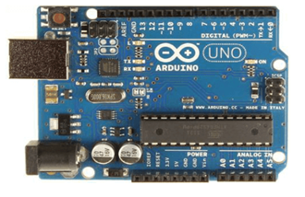

* **Breadboard:** A Breadboard is simply a board for prototyping or building circuits on. It allows you to place components and connections on the board to make circuits without soldering. The holes in the breadboard take care of your connections by physically holding onto parts or wires where you put them and electrically connecting them inside the board. The ease of use and speed are great for learning and quick prototyping of simple circuits.
* **SparkFun Ultrasonic Sensor-HC-SR04:** This is the HC-SR04 ultrasonic distance sensor. This economical sensor provides 2cm to 400cm of non-contact measurement functionality with a ranging accuracy that can reach up to 3mm.
* **Arduino Motor Shield Rev3:** The **Arduino Motor Shield** is based on the L298 ([datasheet](http://www.st.com/web/en/catalog/sense_power/FM142/CL851/SC1790/SS1555/PF63147)), which is a dual full-bridge driver designed to drive inductive loads such as relays, solenoids, DC and stepping motors. It lets you drive two DC motors with your Arduino board, controlling the speed and direction of each one independently.
* **SG90 Micro servo motor:** Micro Servo Motor SG90 is a tiny and lightweight server motor with high output power. Servo can rotate approximately 180 degrees (90 in each direction), and works just like the standard kinds but smaller.
* **Robot Chassis Kit with DC Motors:** This chassis has multiple holes and slots so that you can fit your electronics easily on this rigid chassis. Its made from 3 mm acrylic sheet. holes and standoffs are compatible with Arduino compatible boards so IT can be easily mounted on top.
* **Jumper Wires:** A jumper wire is an electric wire that connects remote electric circuits used for printed circuit boards. By attaching a jumper wire on the circuit, it can be short-circuited and short-cut (jump) to the electric circuit.

**Block diagram & Description**:

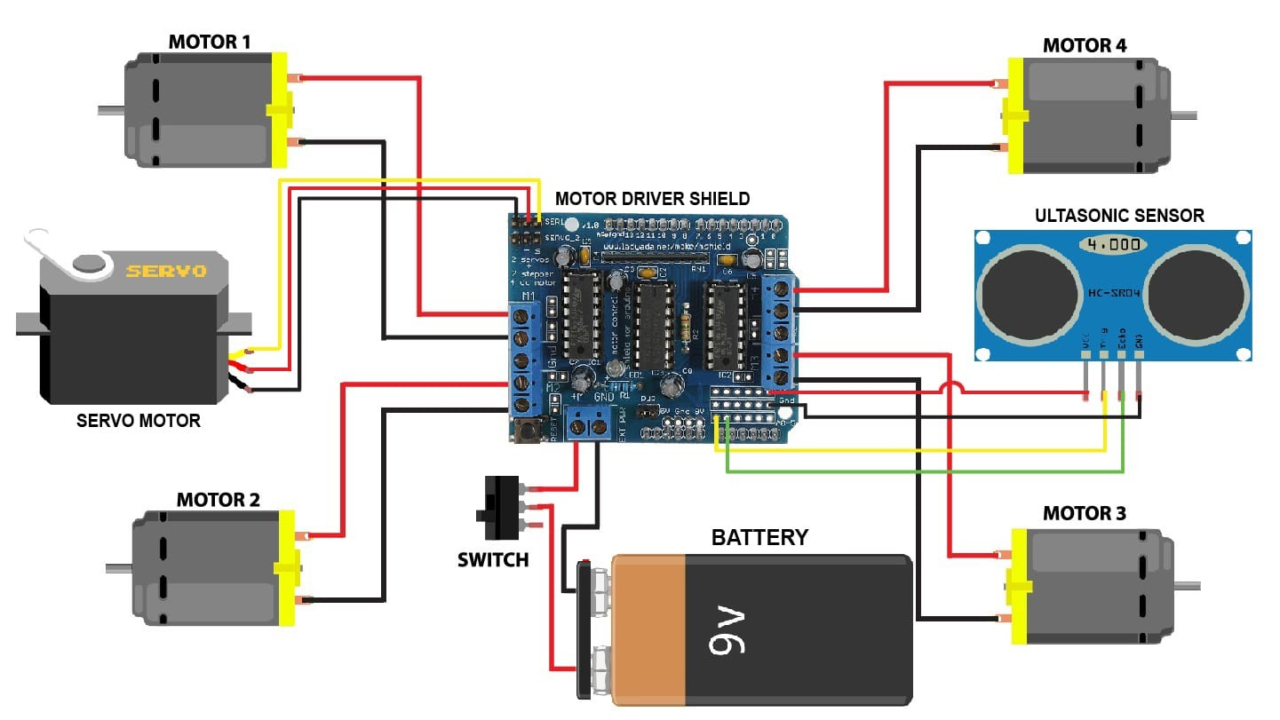

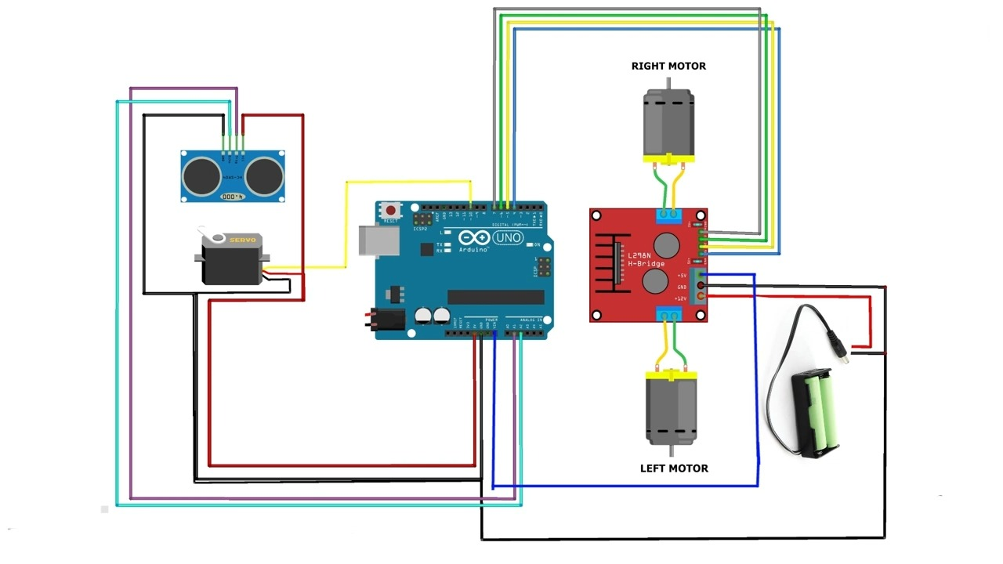

In this project, we’ll combine an ultrasonic sensor with four DC motors and a servomotor to create a simple obstacle-avoiding robot using Arduino. The ultrasonic sensor sends and receives a signal to determine the distance of an object. If there is an object less than 15 centimeters away, the robot will stop. Then it looks around, turns toward a direction in which it doesn’t sense anything, and move in that direction. The ultrasonic sensor is mounted on a servo motor so that the robot can move and search for a clear path.

**Results (Model’s image):**

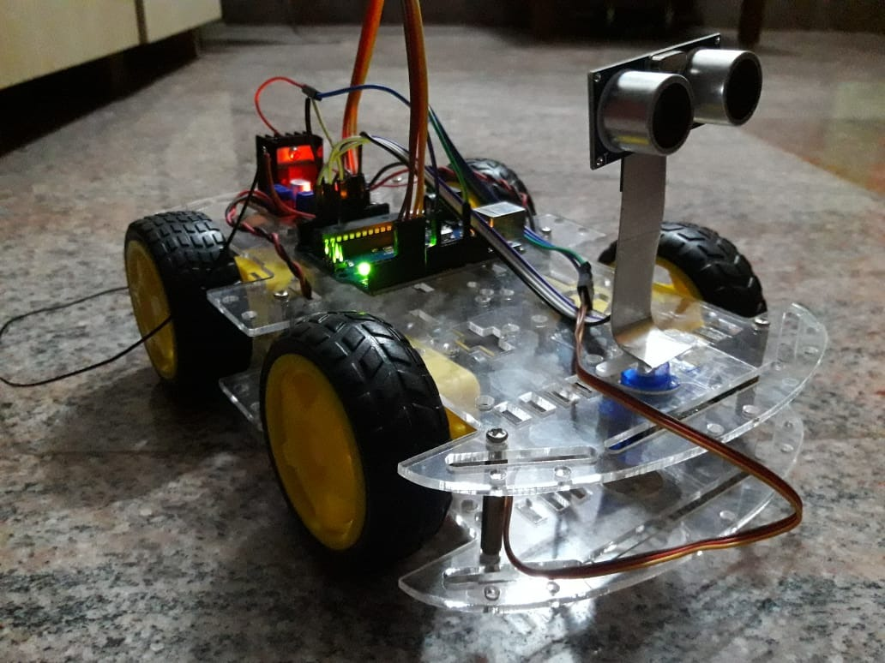

After uploading the code, connect 9-12V DC power supply from battery, the robot car will move forward and when any object is detected in front, the robot automatically turns left or right based on the data received from ultrasonic sensor for any type of obstacle.

**Challenges faced:**

* **Time constraint:** Managing of time to complete the project was proved to be difficult. As most of us belong to different branches , it was hard to meet often.
* **Hardware parts:** There was a lot of difficulty in procuring the hardware parts as most of us are new to this.
* **Less in Person meetings:** Many times the meetings to discuss about the project were postponed.

**Conclusion:**

Robotics is a branch of engineering that involves the conception, design, manufacture and operation of robots. The objective of the robotics field is to create intelligent machines that can assist humans in a variety of ways. Robotics can take on a number of forms.This project is based on Robotics and AI. Now day’s many industries are using robots due to their high level of performance and reliability and which is a great help for human beings. The obstacle avoidance robotics is used for detecting obstacles and avoiding the collision. The design of the obstacle avoidance robot requires the integration of many sensors according to their task. Obstacle detection is the primary requirement of this autonomous robot. The robot gets the information from the surrounding area through mounted sensors on the robot. The sensor used here is the ultrasonic sensor is most suitable for obstacle detection and it is of low cost and has a high ranging capability.